Q1: - Create class diagram of University Registration and using that diagram apply concept of forward engineering in Rational Rose.

Input:-

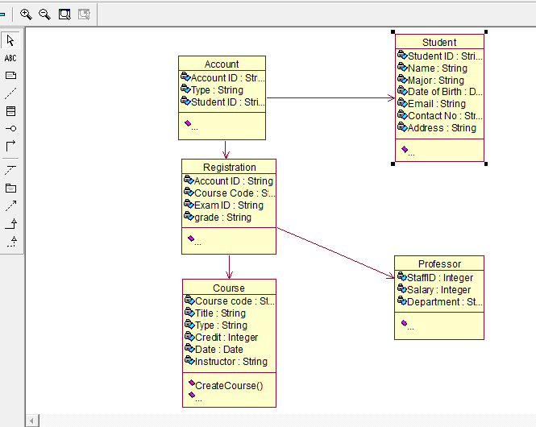

Result:-

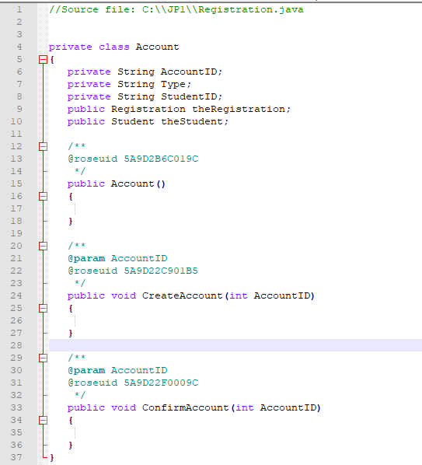

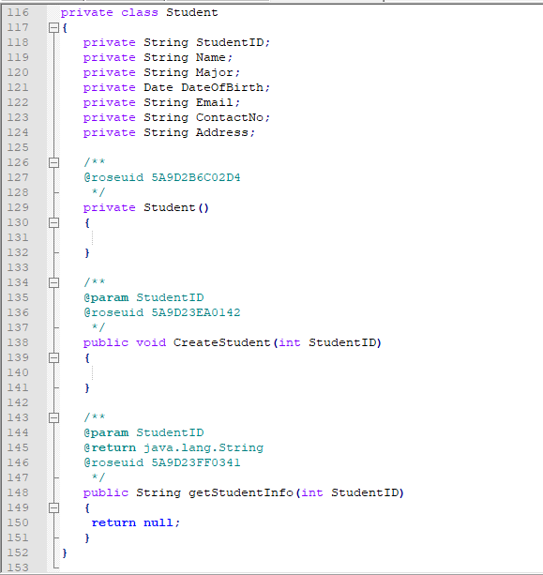

Q2: - Apply concept of reverse engineering to create the class diagram using java code in Rational Rose.

Input:-

private class Account

{

private String StudentID;

public Account()

{

}

public void CreateAccount(int AccountID)

{

}

}

private class Course

{

private String CourseCode;

private Date Date;

private String Instructor;

private Course()

{

}

public void CreateCourse(int CourseCode)

{

}

public void DropCourse(int CourseCode)

{

}

}

private class Professor

{

private Integer StaffID;

private String Department;

private Professor()

{

}

public void CreateProfessor()

{}

public String getProfessorInfo()

{

return null;

}

}

private class Student

{

private String StudentID;

private String Name;

private Date DateOfBirth;

private String Email;

private String ContactNo;

private Student()

{}

public void CreateStudent(int StudentID)

{}

public String getStudentInfo(int StudentID)

{

return null;

}

**}**

Result:-

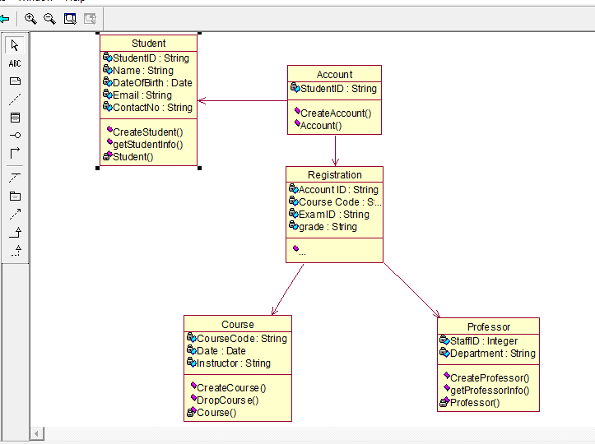

~~~~~~**/**THE END**/**~~~~~~